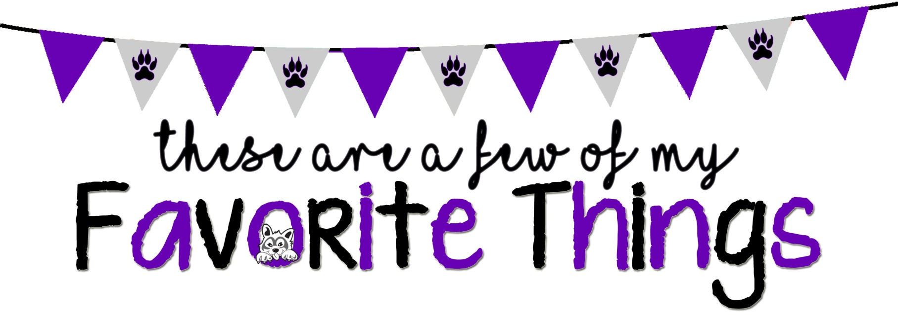
We want to get to know you better, so please fill this form out and return to TLE PTA!
Name: Nicole Morales Grade/Position: 2nd/ELA
Birthday: Feb. 11 Shirt Size: M
Do you have any dietary restrictions? No

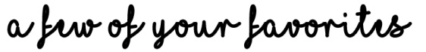

Color(s): blue, green, pink Sports Team(s):
Candy: Gummy Bears/Chocolate Snack: Pretzels, Popcorn, nuts, fruits
Cookie/Cake: Chocolate Chip Dessert: Donuts
Coffee Shop: Starbucks Coffee/Drink: iced coffee, iced tea, lemondae
Restaurant: Fresh Kitchen, Chick fil a Store: target, amazon
Flower: Sunflowers Scent: fruity, floral
Hobby/Collectibles:
Gift Card: Target, Amazon, Starbucks
Other Favorites: I love candles and plants
What are your top classroom supply wishes: flair pens, tape, sticky notes
What can your classroom parents do to help you the most? Just help with anything I need around the classroom and be supportive!

